**AIM :** To use google Lighthouse PWA Analysis Tool to test the PWA functioning.

# THEORY :

Google Lighthouse is an open-source tool developed by Google that helps developers improve the quality and performance of web pages and web applications. It is commonly used to audit and analyze various aspects of a website, including performance, accessibility, best practices, SEO (Search Engine Optimization), and

Progressive Web App (PWA) functionality. Features of Google Lighthouse:

# Audit Capabilities:

* Google Lighthouse can perform audits on different aspects of a web page or web application.
* It evaluates performance metrics such as load time, page speed, and resource optimization.
* It checks accessibility standards to ensure that websites are usable by people with disabilities.
* It assesses best practices to identify areas where coding standards can be improved.
* It analyzes SEO factors to help improve search engine rankings.
* It examines PWA features to verify if a web app meets the criteria for being considered a Progressive Web App.

# Scoring System:

* Lighthouse provides a scoring system for each audit category, ranging from 0 to 100.
* Higher scores indicate better performance, accessibility, best practices, SEO, and PWA compliance.
* The scores are accompanied by detailed information and recommendations for improving each aspect.

# Detailed Reports:

* After running an audit, Lighthouse generates a detailed report that includes scores, metrics, and recommendations.
* The report highlights areas of concern and provides actionable insights to optimize web pages and web apps.

# Integration with DevTools:

* Lighthouse is integrated into Chrome DevTools, making it easily accessible for developers.
* It can be launched directly from DevTools to audit a specific web page or web app.

# Open-Source and Extensible:

* Lighthouse is an open-source tool, allowing developers to contribute to its development and customize its functionality.
* It supports plugins and extensions, enabling additional capabilities and integrations.

# Focus on Performance Optimization:

* One of Lighthouse's primary focuses is on performance optimization, helping developers identify and address issues that impact page load times and user Experience.

# Steps :

To use Google Lighthouse to test the Progressive Web App (PWA) functioning, follow these steps:

# Open Chrome DevTools:

* Open Google Chrome browser.
* Go to the website you want to test as a PWA.
* Right-click on the page and select "Inspect" or press `Ctrl+Shift+I` (Windows/Linux) or `Cmd+Option+I` (Mac) to open Chrome DevTools.

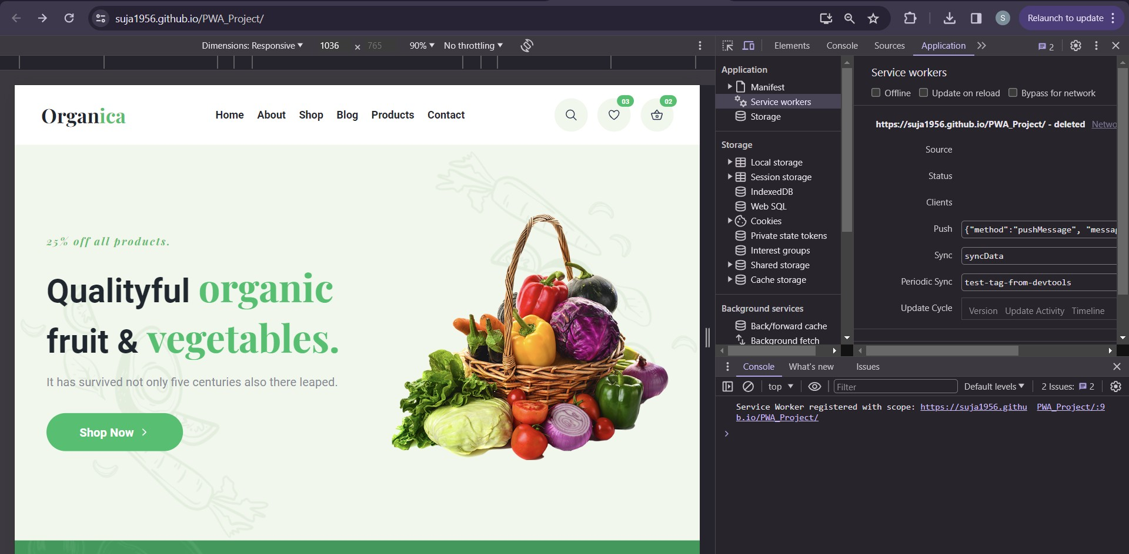

1. **Navigate to the Lighthouse Tab:**

* In Chrome DevTools, click on the "Lighthouse" tab at the top of the DevTools panel.

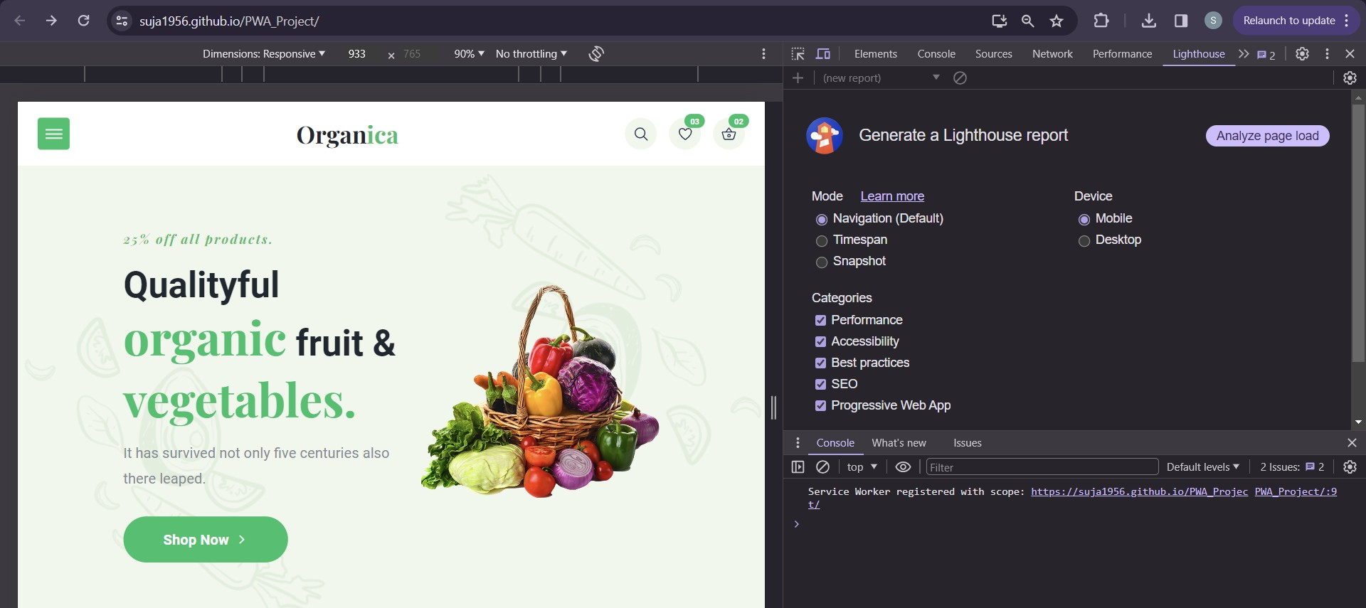

1. **Run the Lighthouse Audit:**

* Click on the "Generate report" button to start the audit process.
* You can choose to audit for Performance, Accessibility, Best Practices, SEO, and Progressive Web App (PWA) functionality. Make sure to select the "Progressive Web App" checkbox.

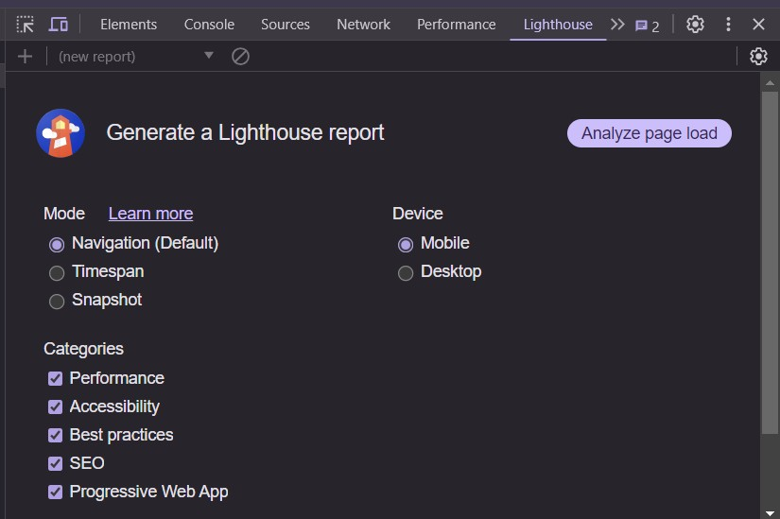

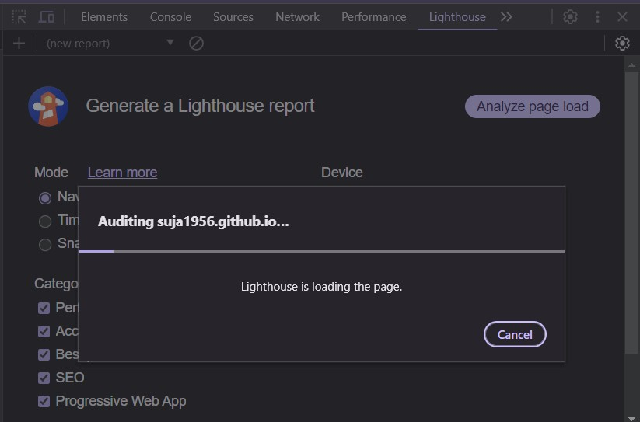

1. **View the Audit Results:**

* After the audit is complete, Lighthouse will display a report with scores and detailed information for each category.
* In the PWA section, you can check if your website meets the PWA criteria, such as having a service worker, being responsive on different devices, having a valid manifest file, etc.
* 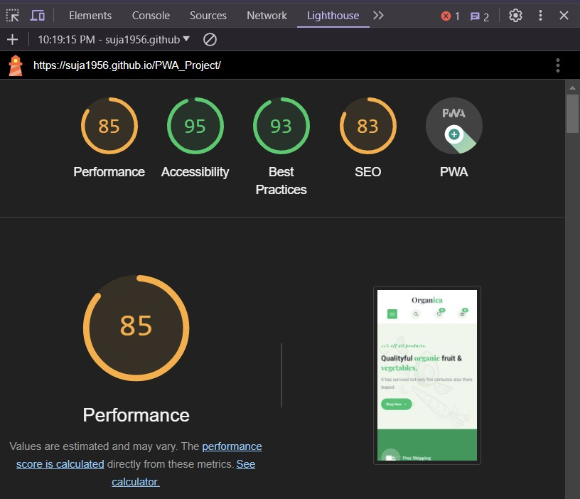Lighthouse will provide suggestions for improvements and optimizations to enhance your PWA functionality.